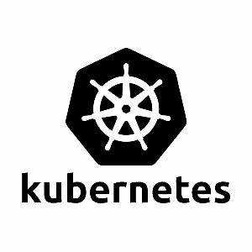

KUBERNETES DEPLOYMENT AND REPLICASETS

KUBERNETES DEPLOYMENT WORKFLOW

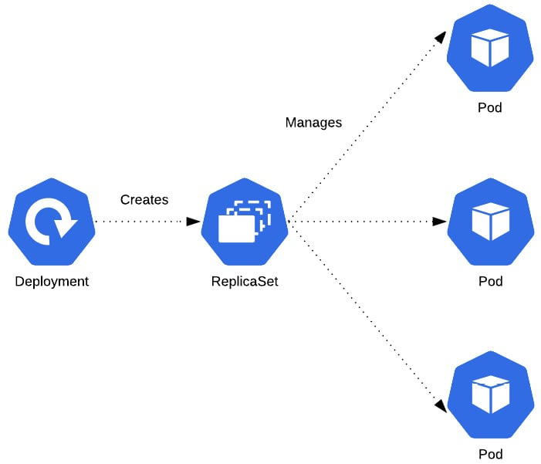

What are Deployments?
A Kubernetes deployment is a resource object that provides declarative updates to applications. It allows you to define the desired state for your application, including the number of replicas, the container image to use, and other configurations.
Management: Deployments manage the creation and scaling of a set of pods ensuring that the specified number of pod replicas is running at all times.
Rollouts and Rollbacks: Deployments support rolling updates, allowing you to update applications without downtime. If an update fails, you can easily roll back to a previous version.

Why are Kubernetes Deployments Useful?
- Scalability: Deployments make it easy to scale applications up or down by adjusting the number of replicas.
- Self-Healing: If a pod fails or is terminated, the deployment automatically replaces it to maintain the desired state.
- Version Control: You can manage different versions of your application easily, facilitating updates and rollbacks.
- Consistency: Deployments ensure that the same application version runs across all environments, reducing discrepancies between development, testing, and production.
Deploy Nginx Server using Deployments:
STEP 1: Start the Kubernetes cluster. You can do that using the below single command. After executing you can see the below output.
$ minikube start
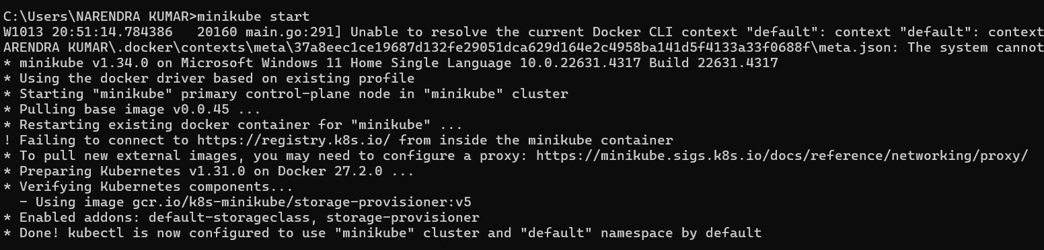

STEP 2: Create a “deployment.yml” file. In deployment.yml file we will specify the number of replicasets. Here in our example, I have given the value as ‘1’.
It means whenever a user or due to any problem if the pod get stopped or deleted the control plane will see this replicasets count in deployment.yml file and it will create new pods automatically in order to maintain the replicasets count in the deployment.yml file.
Below is the sample yml code that deploys Nginx server having replicasets as 1.

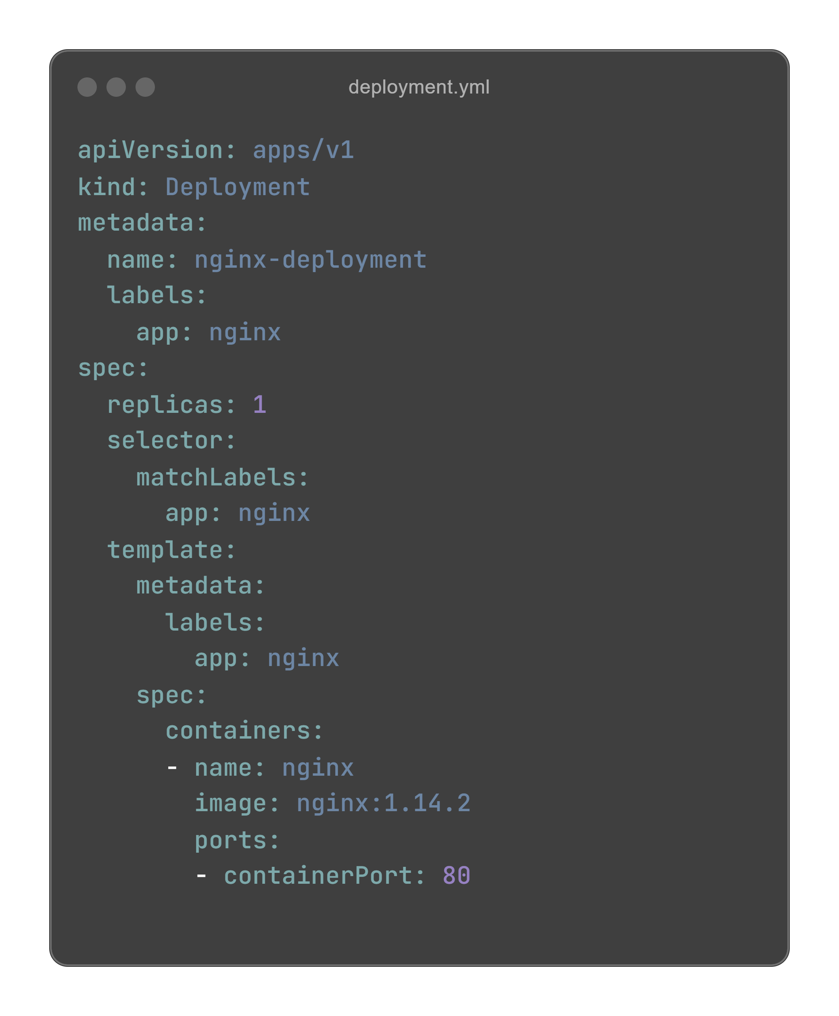
So here for “Kind” parameter we gave value as “Deployment”.

